Chapter 10, Solution 11.

Consider the circuit as shown below.

I_{o} –j5 Ω
+
_

2 Ω 2 Ω
V₁ V₂

j8 Ω
4∠0º V 2I_{o}

At node 1,

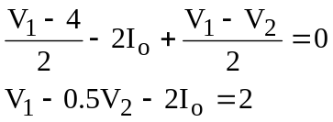

But, I_{o} = (4–V₂)/(–j5) = –j0.2V₂ + j0.8

Now the first node equation becomes,

V₁ – 0.5V₂ + j0.4V₂ – j1.6 = 2 or
V₁ + (–0.5+j0.4)V₂ = 2 + j1.6

At node 2,

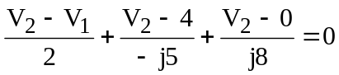
–0.5V₁ + (0.5 + j0.075)V₂ = j0.8

Using MATLAB to solve this, we get,

>> Y=[1,(-0.5+0.4i);-0.5,(0.5+0.075i)]

Y =

1.0000 -0.5000 + 0.4000i
-0.5000 0.5000 + 0.0750i

>> I=[(2+1.6i);0.8i]

I =

2.0000 + 1.6000i
0 + 0.8000i

>> V=inv(Y)*I

V =

4.8597 + 0.0543i
4.9955 + 0.9050i

I_{o} = –j0.2V₂ + j0.8 = –j0.9992 + 0.01086 + j0.8 = 0.01086 – j0.1992

= 199.5∠86.89˚ mA.

